# GEO Documentation

# GEO Submission profile

The link below takes

<https://www.ncbi.nlm.nih.gov/geo/info/submission.html>

* If you have an NCBI account then login

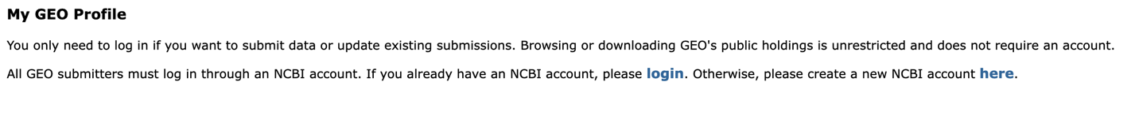

* Else create an account



Below is the GEO profile snippet showing what is required

# GEO Submission steps

The link below takes

<https://www.ncbi.nlm.nih.gov/geo/info/submission.html>

The link below takes you to Submit high-throughput sequencing

<https://www.ncbi.nlm.nih.gov/geo/info/seq.html>

The template for the metadata spreadsheet can be found by clicking the link on the page

Or you can use the link below:

<https://www.ncbi.nlm.nih.gov/geo/info/examples/seq_template.xlsx>

Once you have created and account you will have a personalized upload space

<https://www.ncbi.nlm.nih.gov/geo/info/submissionftp.html>

You can transfer the files through ftp or filezilla

The examples below gives examples on how to transfer and login

# GEO Submission file transfer

Create a geo submission directory within the personalized upload space

Eg. Geo_submission_2022

Upload your processed files, raw data and the metadata sheet using [link](https://www.ncbi.nlm.nih.gov/geo/info/seq.html) as a guideline to processed files accepted.

# Notify GEO of your submission

Once all the files are transferred click on the link below:

<https://submit.ncbi.nlm.nih.gov/geo/submission/>

Below is the example of notifying GEO once the transfer is completed.

